**AWS CODE BUILD HANDS ON**

<https://github.com/vishwanathacharya/code-build-demo.git>

In This Repository All files are available and buildspec.yaml file also

Go to AWS Management Console & Create S3 bucket -> airtifacts & destination

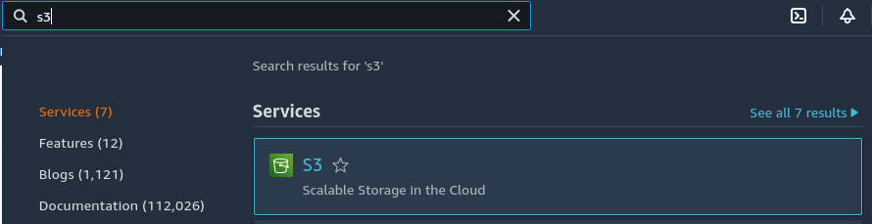

Open S3 Service

Create Artifact-db

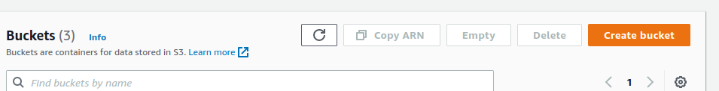

Bucket name

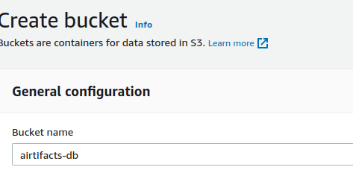

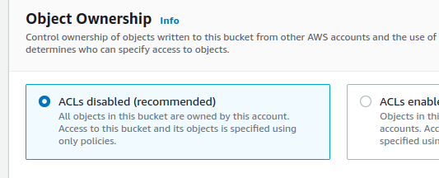

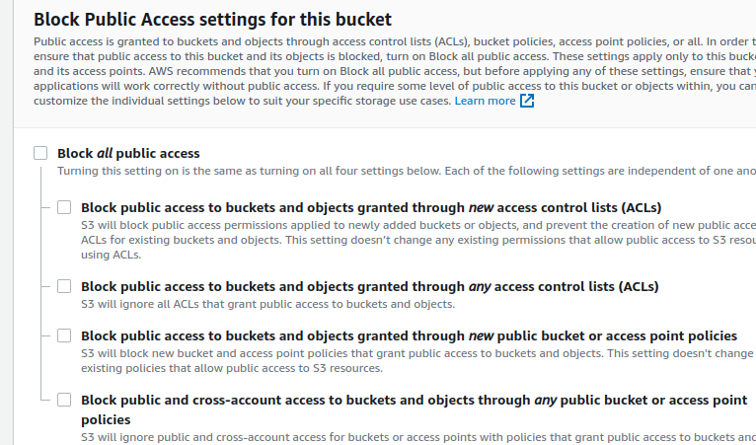

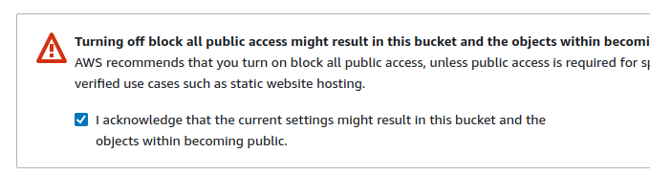

Enable Versioning

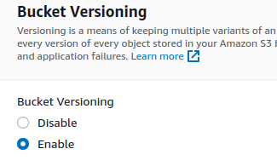

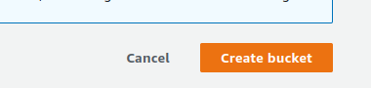

Create Another S3 Bucket Destination-db

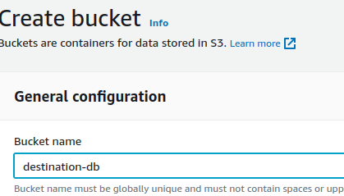

Same process for this & Create Bucket

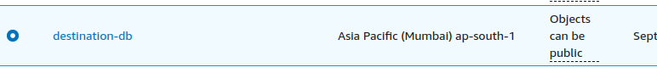

Open Destination-db

Go TO properties

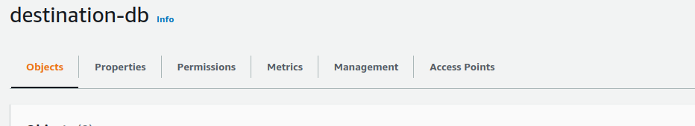

Click ON Properties

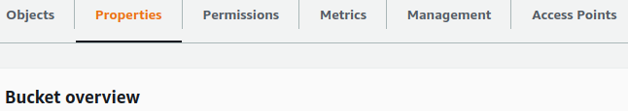

Edit Server ACCESS login

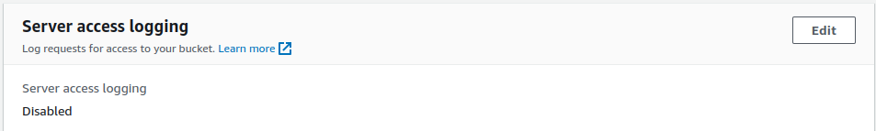

Enable Server Access Login

Choose Target Destination Bucket

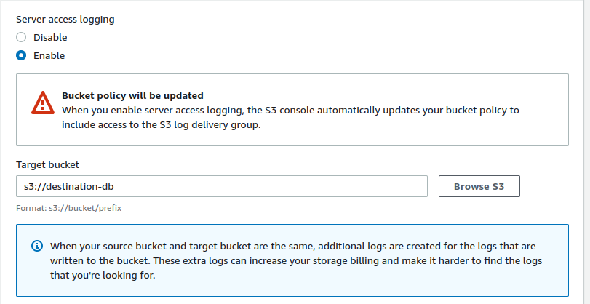

Choose your Target bucket

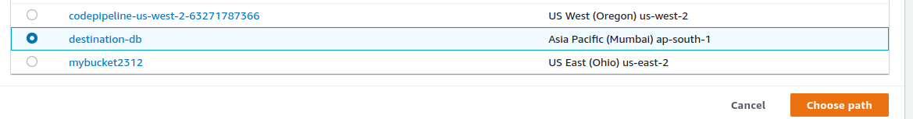

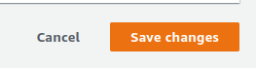

Save

Enable static website hosting

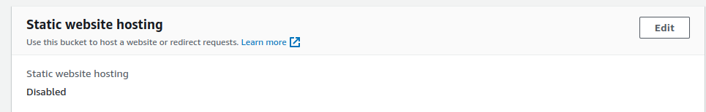

Add index.html

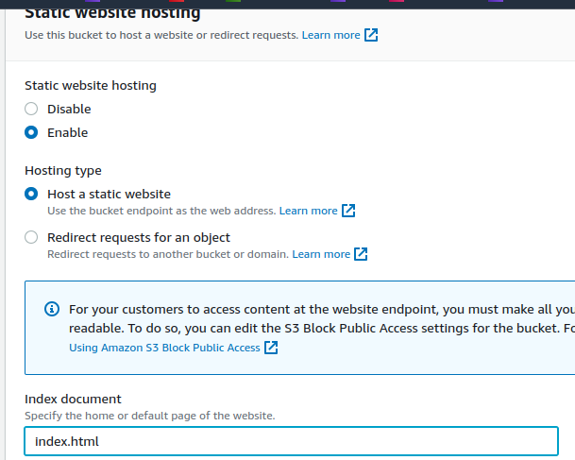

Go To the Permission

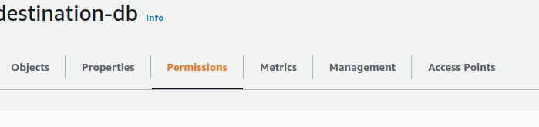

Edit Bucket Policy

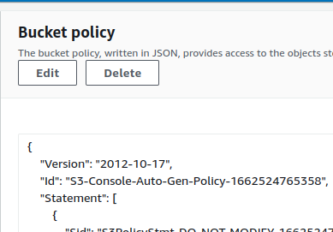

{

"Version": "2012-10-17",

"Statement": [

{

"Sid": "PublicRead",

"Effect": "Allow",

"Principal": "*",

"Action": [

"s3:GetObject",

"s3:GetObjectVersion"

],

"Resource": [

"arn:aws:s3:::destination-db/*"

]

}

]

}

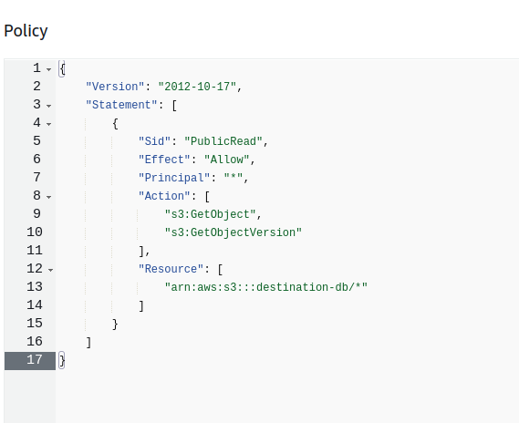

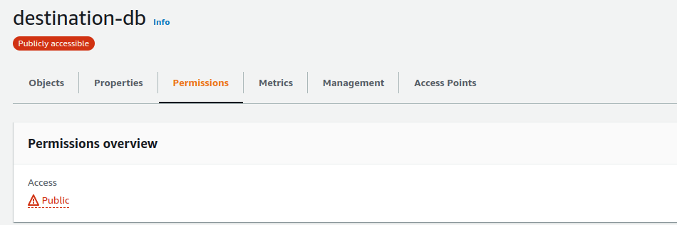

Go To AWS Code Build Service

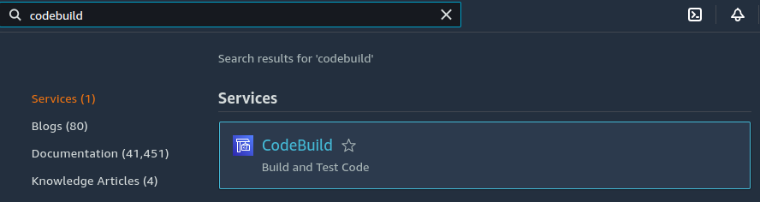

Open AWS Code Build

Create Build Project

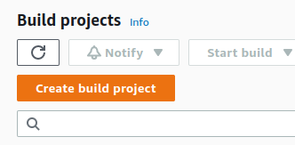

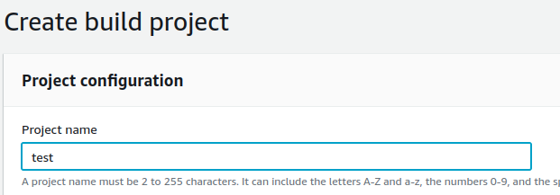

Choose Source Provider

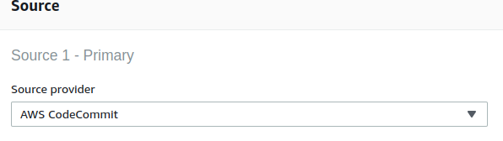

Choose Your Repository

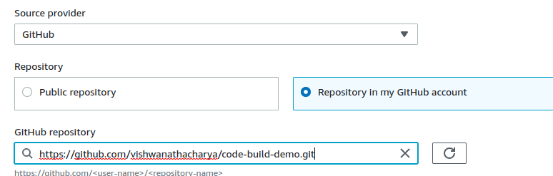

Choose Your Environment Machine

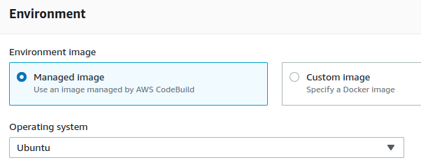

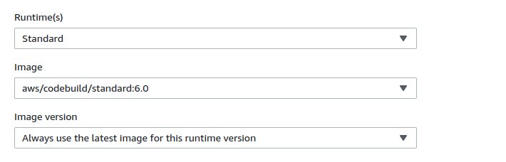

Choose Service Role otherwise it Create self Role

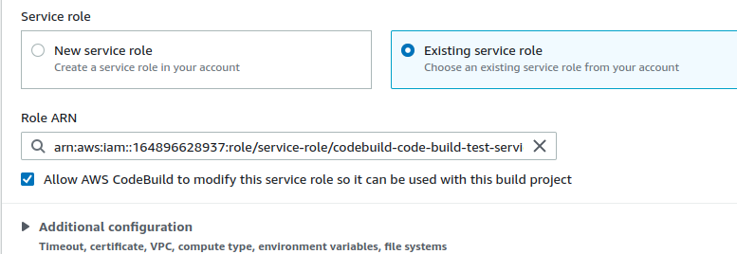

Log open or enable

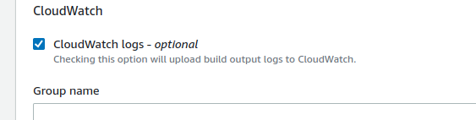

Create Build

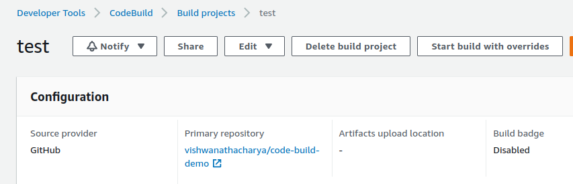

Go to AWS Pipeline Service & build pipeline

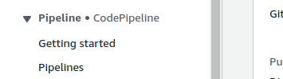

Create pipeline

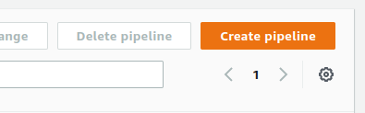

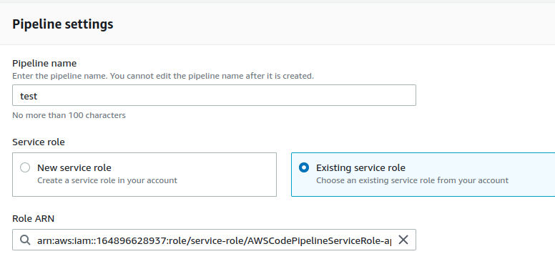

Choose or Create New service role

Choose your Aitifact-db for store your buildartifacts

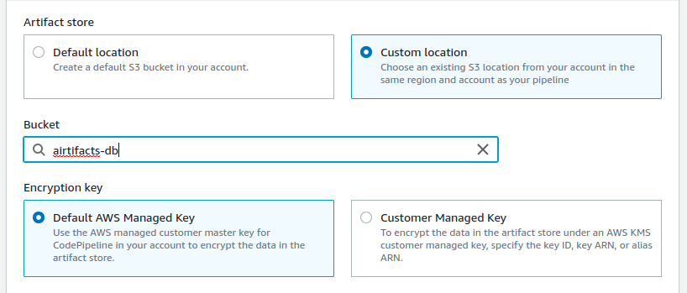

NEXT

Choose your Source provider

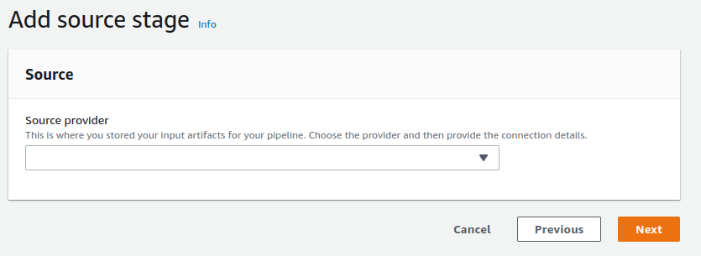

Choose Your Repository Store

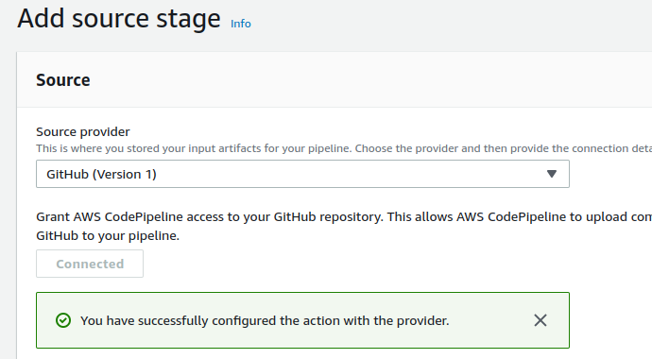

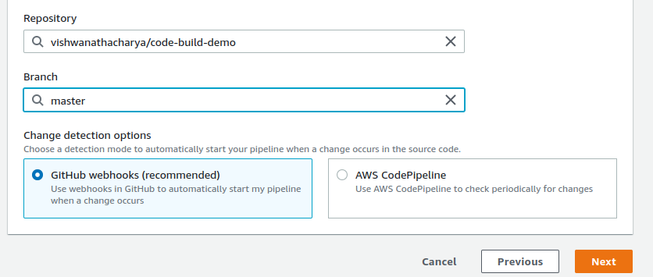

Select Repository & Branch

Add Build Stage

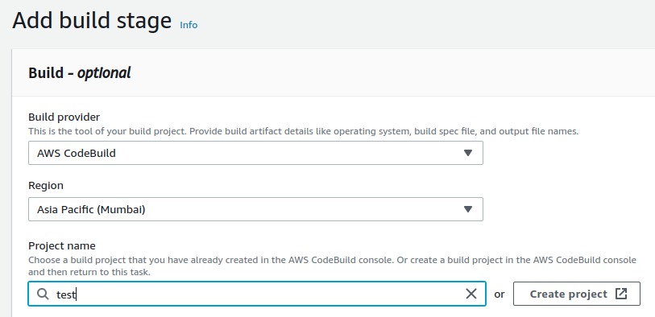

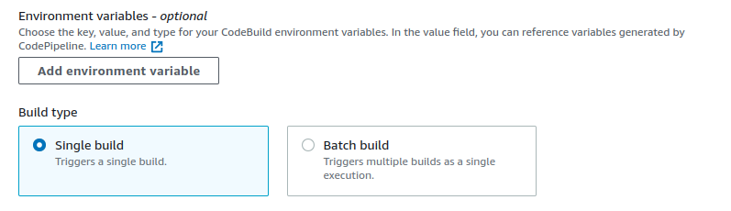

Add Deploy Stage

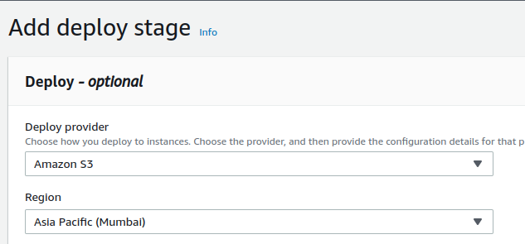

S3 Destination-db

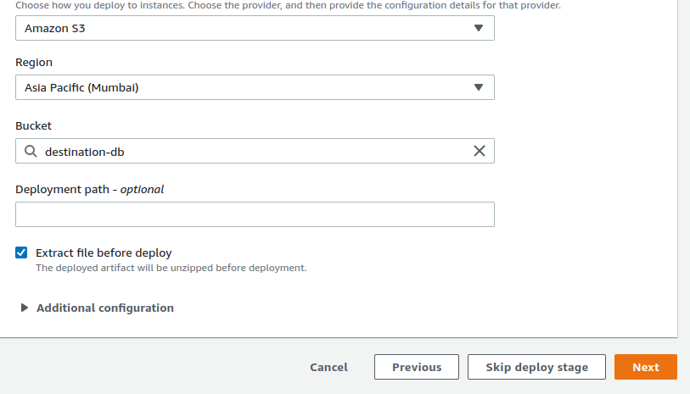

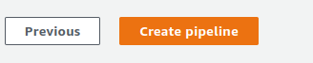

Create Pipeline

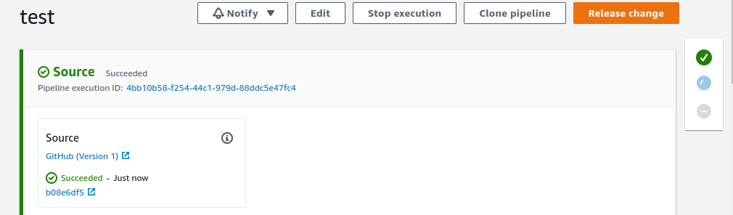

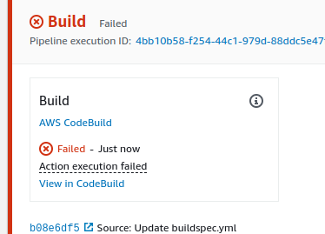

Check Logs

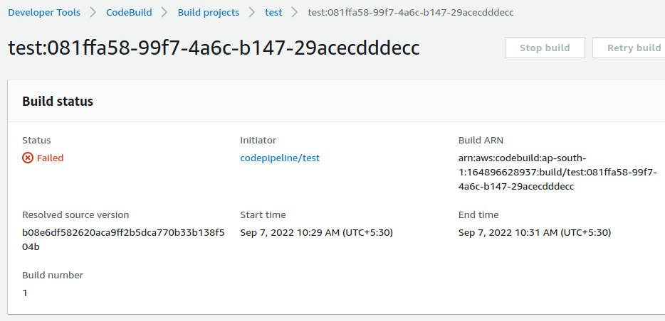

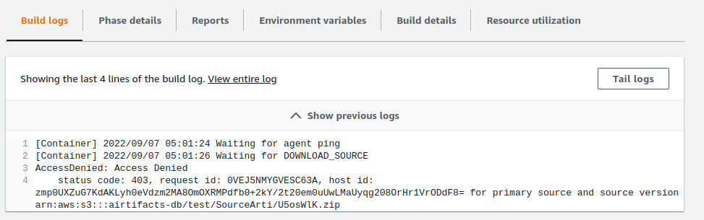

Go to Build details



Open Service Role

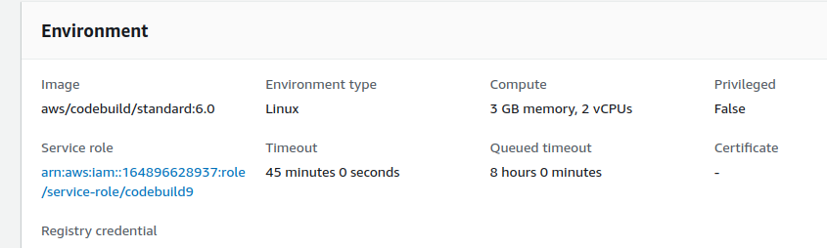

Open IAM Service Role

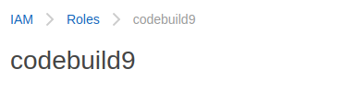

Attach s3 full access policy role

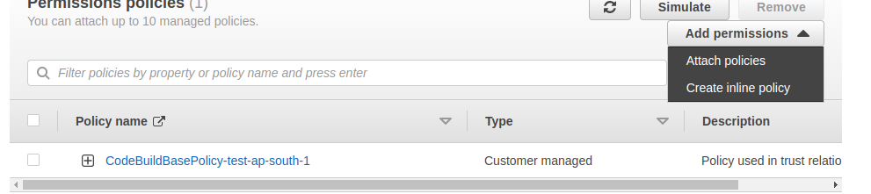

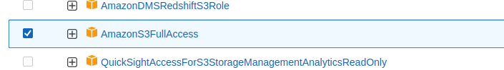

Attache s3fullaccess

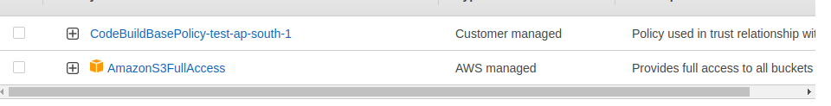

Retry build

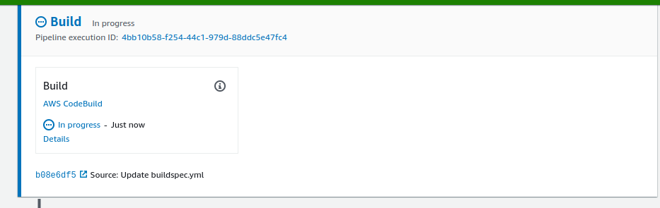

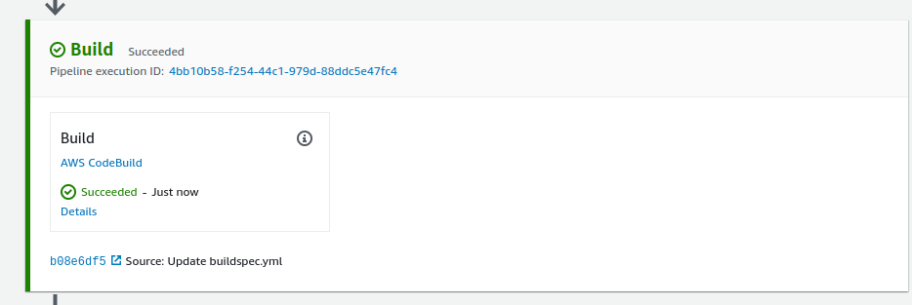

Deploye code on S3 destination-db

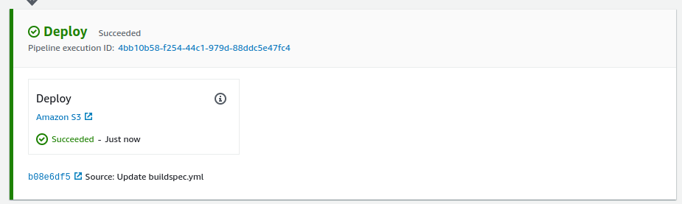

Open S3 Service



Open destination-db

Here is Your Deploy code

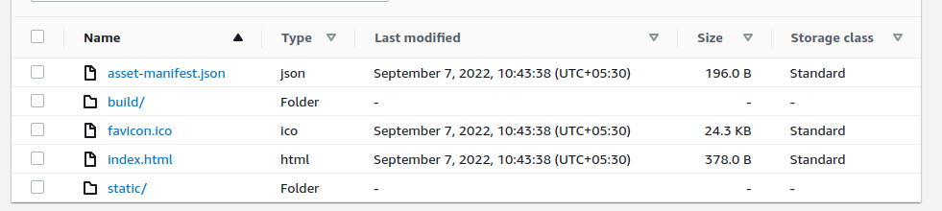

Go to properties

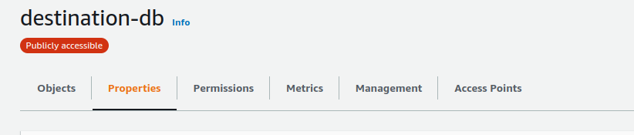

Open URL Static WEBSITE hosting

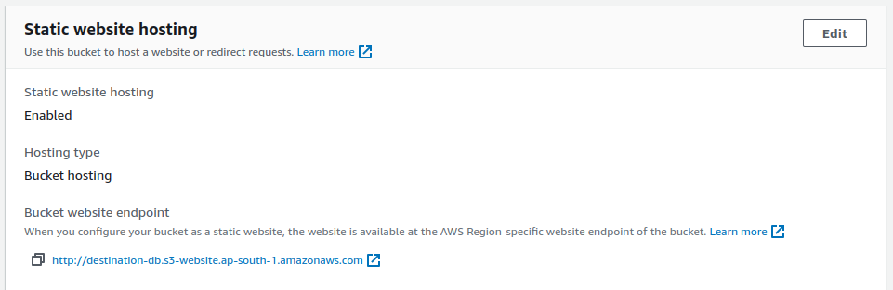

<http://destination-db.s3-website.ap-south-1.amazonaws.com>

